

Prepared by:

**Gerber Technology**

**YuniquePLM**

**Sample Dashboard**

The Sample Dashboard is an area where each user can view all outstanding samples filtered by specific agent(s) as well as generate new samples. The samples can be arranged in a list or calendar view. To access the Sample Dashboard, click on the **Sample View** from the left navigation.

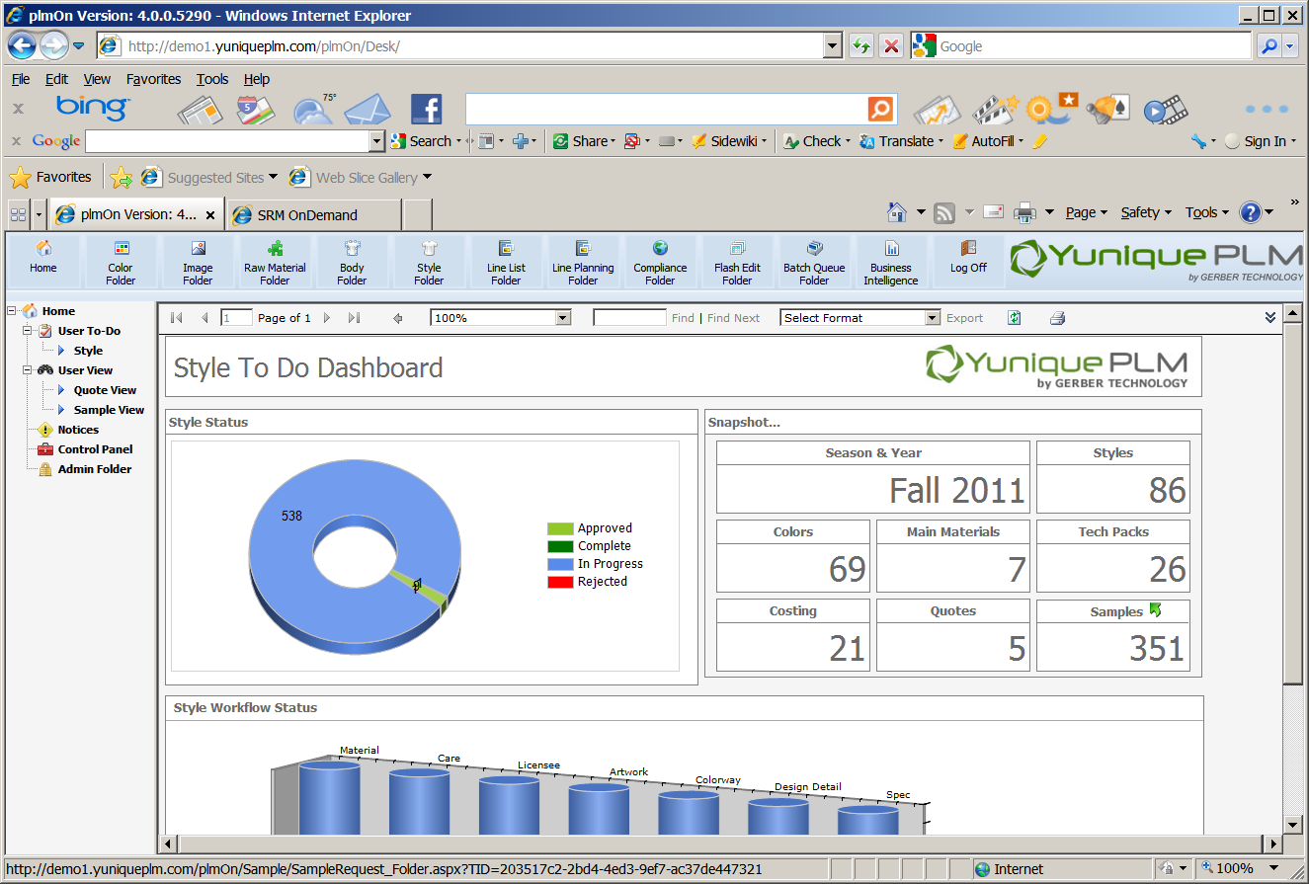

Once the sample folder is presented it will be blank except for the nodes on the left side of the explorer window. Each user will be able to customize the list presented in the sample folder by clicking on the Filer Submit node.

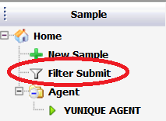

The list of available agents will be presented on the left. Agent names can be highlighted and then moved to the selected list on the right using the green control arrows in the center.

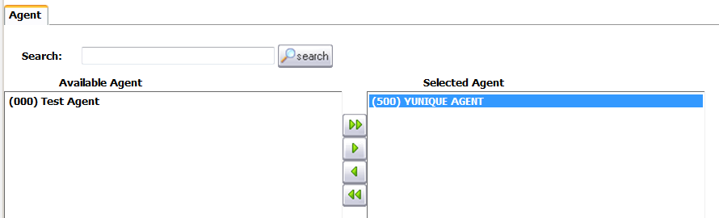

Clicking on the Save button across the top of the screen will store the new filter settings.



Once the list has been filtered by agent(s), the type(s) of samples need to be selected on the Submit tab. Select the sample type(s) from the Available list on the right and move them to the Selected list on the right by using the green control arrows in the center.

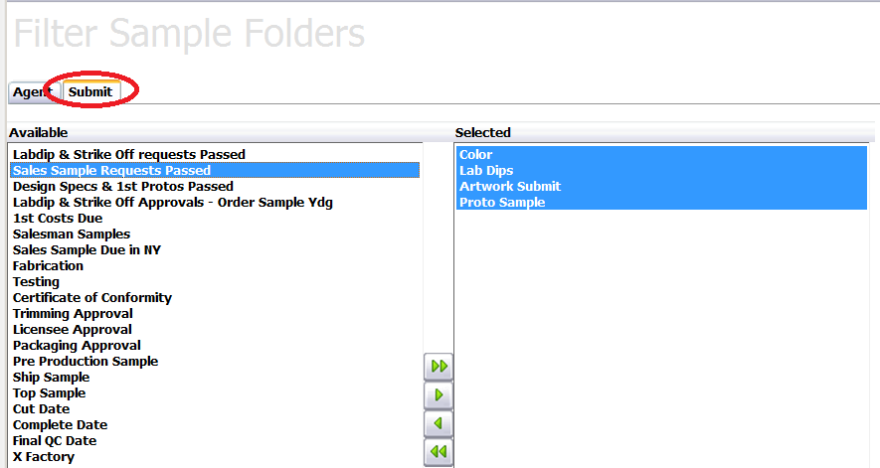

Once all of the sample filters are set, click on the Save button in the upper left to store the new record.



Once the agents have been selected from the list a node will be added on the left side of the explorer window for each agent.

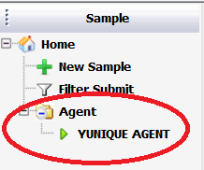

Click directly on the agent node to view a list of the selected sample submits on the right hand side of the explorer window.

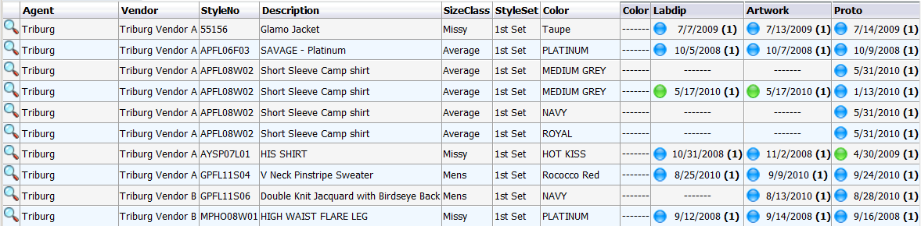

Each row will display a specific style sample request for the selected vendor. At the far right end of each row, a column will be listed for each of the submit types that were selected. The due date for each of the sample request will be listed beneath the corresponding header. A colored “bubble” indicator will also be visible as a quick reference. If there was no request made for the specific style then a double dash (---) symbol will appear instead of a date.

A user can open up an individual sample record by double clicking on the date beneath a specific sample type header.

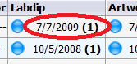

The workflow record will be open and users will be able to review and edit any of the information according to group permissions.

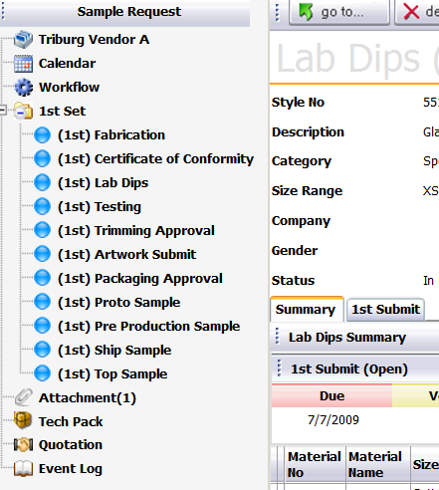

Users can also review all overdue records by clicking on the Late Submit(s) tab. The records can be opened by clicking directly over the submit date listed.

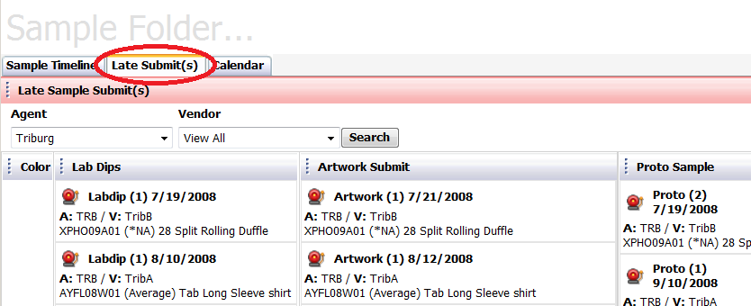

All records can be viewed by day, week or month on the Calendar tab. Records can be opened by clicking directly over the submit name listed.

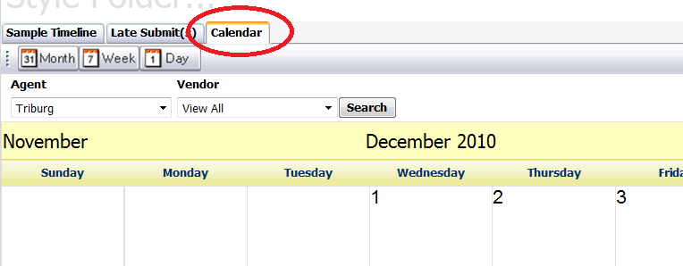

The filter settings can be changed on an as needed basis allowing each individual user to access information easily for a variety of business needs.